

**Trimester: I/II/III Subject: Programming and Problem Solving**

**Name**: Krishnaraj Thadesar **Division:** 9

**Roll No.:** 109054 **Batch:** I3

**Experiment No.:** 11

**Name of the Experiment:** Python program to sort print number of upper and lower case letters in a given string.

**Performed on:** 28rd February 2022

**Submitted on:** 28st February 2022

**AIM**: Write a Python function that accept a string and calculate the number of uppercase and lowercase letter.

**OBJECTIVE:**

1. To learn a isupper() and islower() functions in python**.**

**THEORY:**

**Function**:

A *function* is a set of statements that take inputs, do some specific computation and produces output. The idea is to put some commonly or repeatedly done task together and make a function, so that instead of writing the same code again and again for different inputs, we can call the function. Python provides built-in functions like print(), etc. but we can also create your own functions. These functions are called user-defined functions.

**isupper():** Python String  *isupper()* and *islower()* Methods with Examples, these are the in-built methods in Python, which are used to check whether a string is in Uppercase or Lowercase. isupper() and islower() both are the in- built methods in Python which works with the strings.

**islower():** *islower()* is a built-in method used for string handling. The islower() methods returns “True” if all characters in the string are lowercase, Otherwise, It returns “False”.

Ex.

def string_test(s):

d={"UPPER_CASE":0, "LOWER_CASE":0}

for c in s:

if c.isupper():

d["UPPER_CASE"]+=1

elif c.islower():

d["LOWER_CASE"]+=1

else:

pass

print ("Original String : ", s)

print ("No. of Upper case characters : ", d["UPPER_CASE"])

print ("No. of Lower case Characters : ", d["LOWER_CASE"])

*string_test('The quick Brown Fox')*

# PLATFORM: *ArchLinux 64 Bit with python 3.10.1 from AUR.*

# ALGORITHM:

Step 1: Take a string from the user and store it in a variable.  
Step 2: Initialize the two count variables to 0.  
Step 3: Use a for loop to traverse through the characters in the string and increment the first count variable each time a lowercase character is encountered and increment the second count variable each time a uppercase character is encountered.  
Step 4: Print the total count of both the variables.  
Step 5: Exit.

# Flowchart:

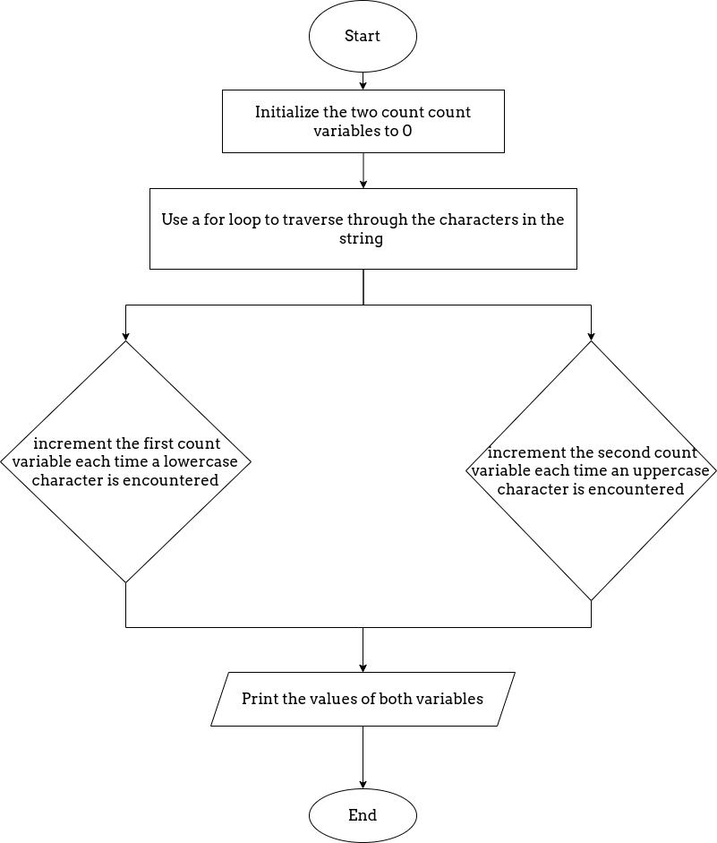

# CODE:

# Program to Print the number of upper and lower case characters in a given string.

print('Enter the string you want to calculate upper and lower case characters of: ')

user_string = input()

upper_count = 0

lower_count = 0

for i in user_string:

    if i.isupper():

        upper_count +=1

    elif i.islower():

        lower_count +=1

print('The numeber of upper case characters in the given string are: ', upper_count)

print('The numeber of lower case characters in the given string are: ', lower_count)

**OUTPUT**

Enter the string you want to calculate upper and lower case characters of:

Upper

The numeber of upper case characters in the given string are:  1

The numeber of lower case characters in the given string are:  4

**CONCLUSION:**

Thus, understood the function writing and in build functions isupper(), islower() in Python

**FAQs:**

1. **What isupper()function returns()?**

isupper() is a built-in method used for string handling. This method returns True if all characters in the string are uppercase, otherwise, returns “False”.

# What islower() function returns?

is a built-in method used for string handling. The islower() method returns True if all characters in the string are lowercase, otherwise, returns “False”. This function is used to check if the argument contains any lowercase characters

# What is function in python?

A function is a set of statements that take inputs, do some specific computation and produces output. The idea is to put some commonly or repeatedly done task together and make a function, so that instead of writing the same code again and again for different inputs, we can call the function. Python provides built-in functions like print (), etc. but we can also create your own functions. These functions are called user-defined functions.

# Explain def keyword.

def is a keyword (case-sensitive) in python, it is used to define a function, it is placed before the function name (that is provided by the user to create a user-defined function). Syntax of def keyword def function_name: function definition statements